**BITP 3113**

**OBJECT ORIENTED PROGRAMMING**

**PROJECT:**

**ERRANDS RUNNING SYSTEM – PHASE 1**

**LECTURER NAME:**

**DR EMALIANA BINTI KASMURI**

**STUDENT NAME:**

**MUHAMMAD AFIQ MUHAIMIN BIN MOHD ZAINI**

**AZMEEN SYAHMI BIN MD FAIRUZ**

**MUHAMMAD HADI BIN SUPARMAN**

**NURAZYMAN BIN AHAMAD**

**PEH JIA DA**

**MATRIC NUMBER:**

**B032410648**

**B032410681**

**B032410672**

**B032410675**

**B032410901**

**SEMESTER: 2-2024/25**

Identify the entity/domain classes for your project.

**Model**

|  |  |  |
| --- | --- | --- |
| **Class** | **Fields** | **Methods** |
| **User *(abstract)*** | * **id: int,** * **name: String** * **email: String** * **password: String** | * **login(): boolean,** * **logout(): void** |
| **Customer** | * **requestHistory: List<Errand>** | * **submitRequest(errand: Errand): void,** * **viewStatus(errandId: int): String** |
| **Runner** | * **schedule: Schedule,** * **performanceStats: PerformanceStats,** * **assignedErrands: List<Errand>** | * **markCompleted(errandId: int): void,** * **updateAvailability(): void** |
| **Errand** | * **id: int,** * **type: String,** * **description: String,** * **pickupAddress: String,** * **dropoffAddress: String,** * **status: String,** * **assignedRunner: Runner** | * **assignRunner(runner: Runner): void,** * **updateStatus(newStatus: String): void** |
| **Quote** | * **id: int,** * **amount: float,** * **createdAt: datetime** | * **generate(): float** |
| **Payment** | * **paymentId: int,** * **method: String,** * **status: String** | * **process(amount: float): boolean** |
| **Schedule** | * **availableSlots: List<TimeSlot>** | * **isAvailable(time: datetime): boolean** |
| **TimeSlot** | * **startTime: datetime,** * **endTime: datetime** | * ***(none)*** |
| **PerformanceStats** | * **completed: int,** * **rating: float** | * **updateRating(newRating: float): void** |
| **Communication** | * **messages: List<Message>** | * **sendMessage(to: User, content: String): void** |
| **Message** | * **timestamp: datetime,** * **sender: User,** * **content: String** | * ***(none)*** |

**View**

|  |  |  |
| --- | --- | --- |
| **Page / Component** | **UI Elements / Fields** | **Purpose** |
| **LoginPage** | Email input, Password input, Login button | User authentication |
| **CustomerDashboard** | Request History Table, Submit New Errand Button, Errand Status Display | Customer manages and views errands |
| **ErrandRequestForm** | Pickup Address, Drop-off Address, Description, Submit button | Form to request a new errand |
| **RunnerDashboard** | Assigned Errands List, Mark Complete Button, Availability Toggle | Runner views and updates assigned errands |
| **AvailabilityForm** | Time Slot Selector, Submit Availability Button | Runner updates availability |
| **QuoteDisplay** | Quote Amount, Details of Services, Accept Quote Button | Displays cost quote to customer |
| **PaymentPage** | Payment Method, Card Info, Submit Payment Button | Process payment |
| **ChatInterface** | Message Box, Send Button, Message History | Messaging between runner and customer |

**Controller**

|  |  |
| --- | --- |
| **Controller Class** | **Methods** |
| **UserController** | * **login(),** * **logout(),** * **register()** |
| **CustomerController** | * **submitErrand(),** * **viewHistory()** |
| **RunnerController** | * **viewAssignedErrands(),** * **markCompleted()** |
| **ErrandController** | * **createErrand(),** * **updateStatus(),** * **assignRunner()** |
| **QuoteController** | * **getQuote(),** * **viewQuoteDetails()** |
| **PaymentController** | * **makePayment(),** * **getPaymentStatus()** |
| **MessageController** | * **sendMessage(),** * **viewMessages()** |

**UML Class Diagram**

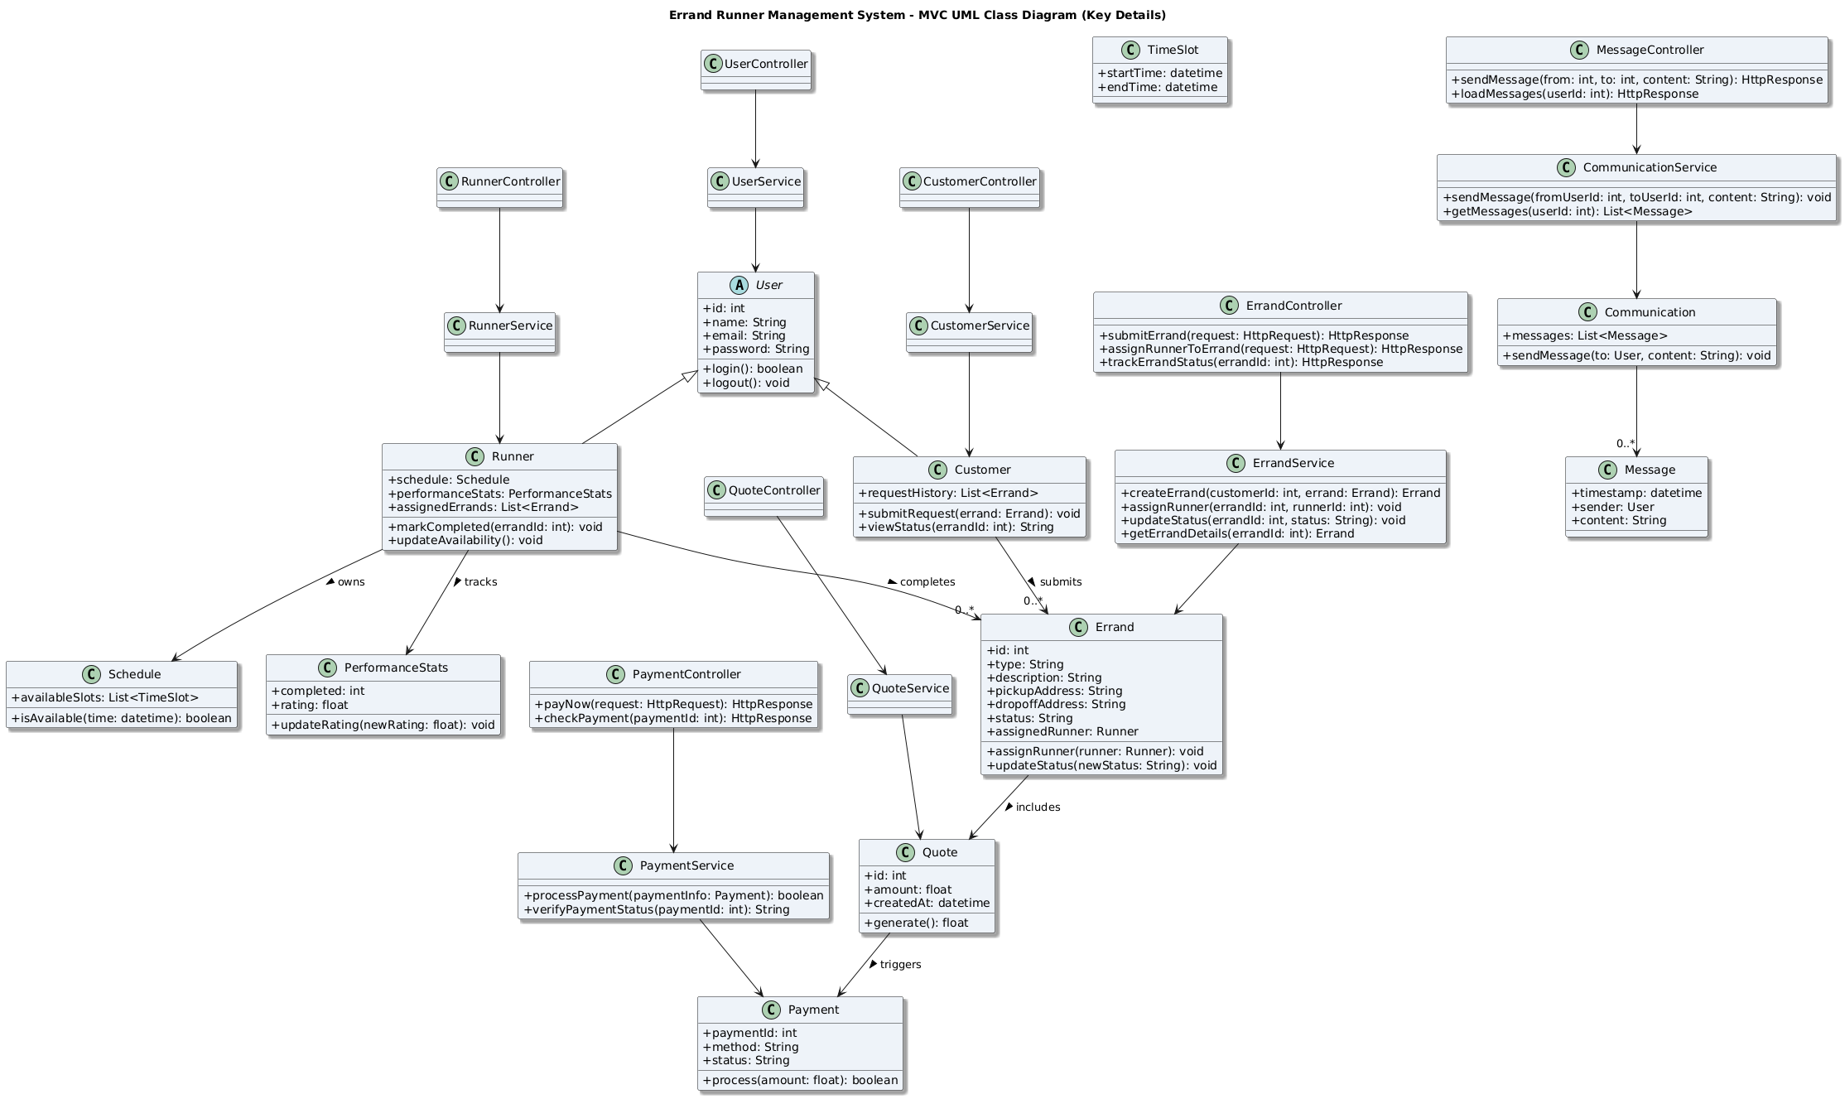

# Login Page



**Create New Account**

Already Registered? **Login**

N A M E

Lorem Ipsum

E M A I L

Lorem [Ipsum@greatsite.com](mailto:Ipsum@greatsite.com)

P A SSWO R D

******

**sign up**



**Login**

Sign in to continue

E M A I L

Lorem [Ipsum@greatsite.com](mailto:Ipsum@greatsite.com)

P A SSWO R D

******

**sign up**

# Customer Dashboard





**Send new Parcel**

View request History Errand status tracking

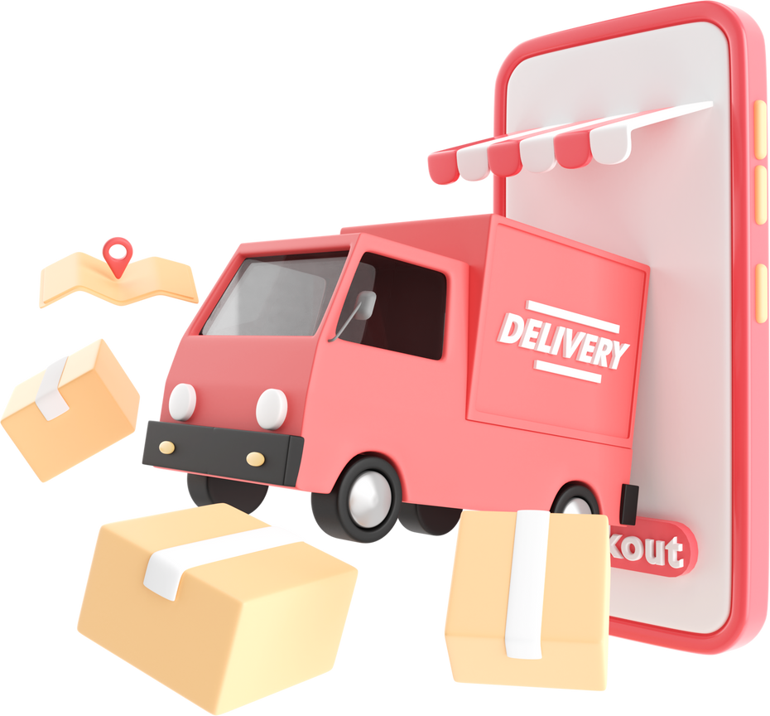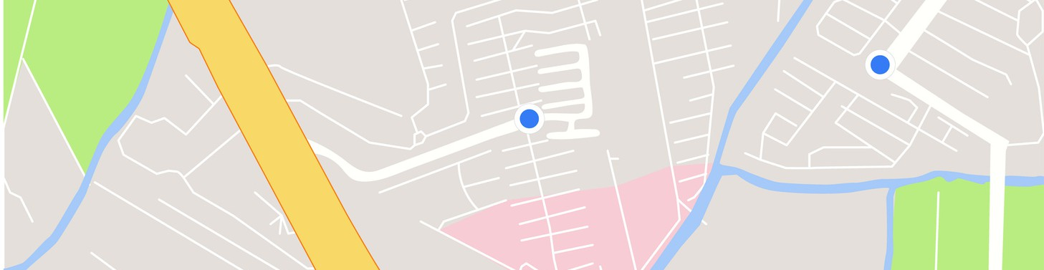

SIGN UP FOR FREE

**Join as merchant**

or

TRACK YOUR PARCEL

Tracking id TRACK

Phone Number

(viewStatus)

List of active/ completed errands

# Submit New Errand Page

## From Postcode To poscode Weight

**KG**

## Calculate

Submit New Delivery details: Fields for:



Type Description

Pickup & Drop-off addresses

Estimated Quote/Amount shown TAC

Button to submit request Trigger for payment page

# Payment Page



Bank 1

Bank 2

Payment method selection TAC

Key in detailed online banking / card

Sumarize order deliveryAmount to pay "Confirm & Pay" button Confirmation message



Order complete notification Summarize info customer order delivery

Estimate day

Generate Tracking Number

# Runner Dashboard

**Schedule Page**

Show performance: completed count & average rating

All List of assigned errands

Mark errand as completed



View/update availability

Message Customer Display

# Runner Schedule Page

**Runner Dashboard**



Manage available time slots

Calendar/time selector

Save/update availability

# Communication / Messages



Inbox-style message view

Chat or message view with sender and content Send message to another user (via sendMessage)